**NAME - KARAN MISHRA  
DIV - D15B  
ROLL NO - 36  
ADV, DEVOPS 12**S3 Bucket:-  
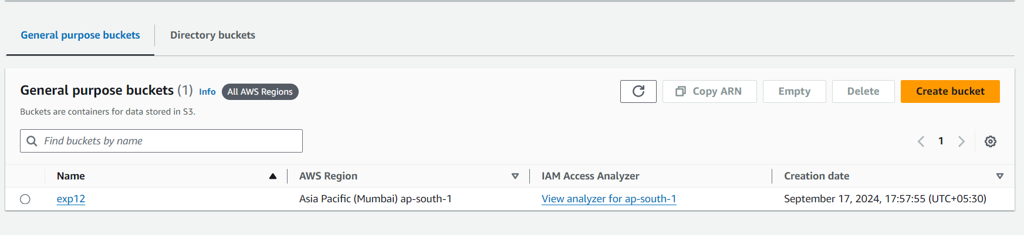  
Uploading An Image:-

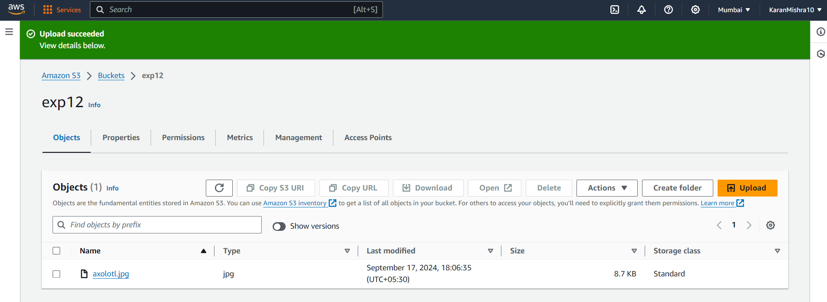

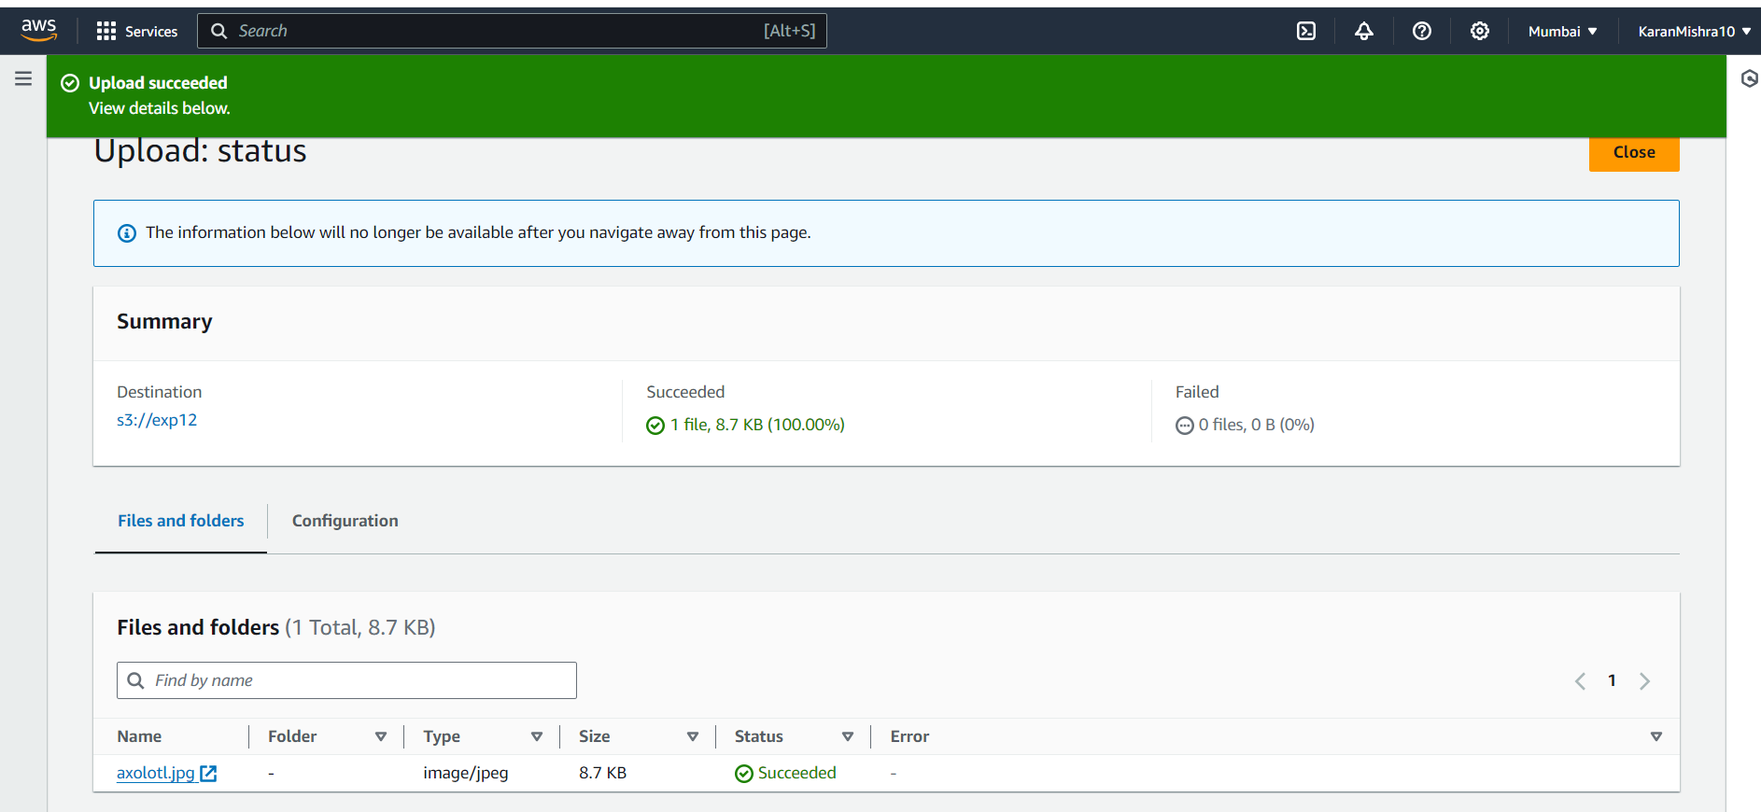

Lambda Function:-

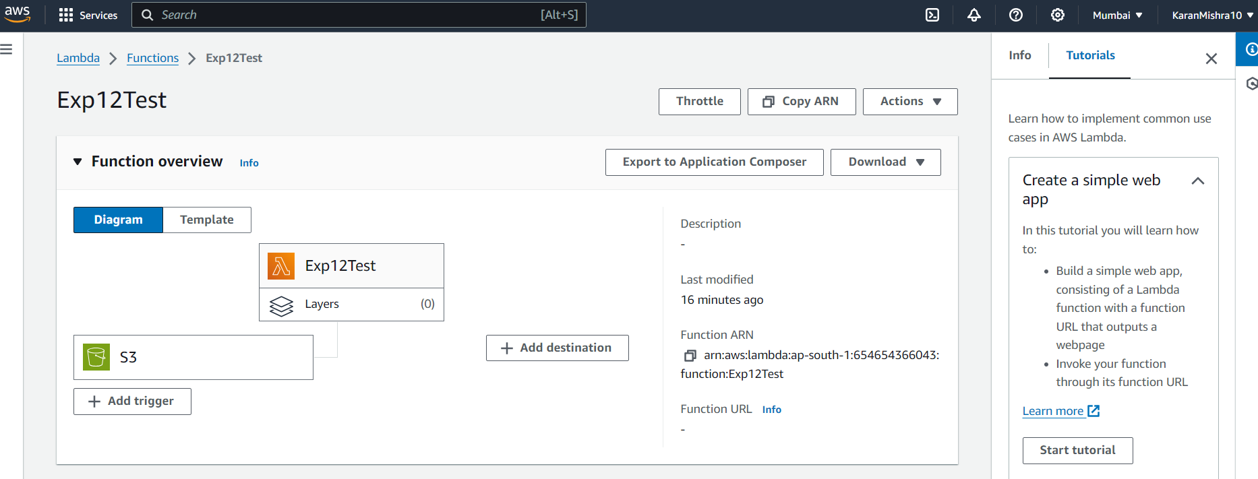

Changing the Code:-

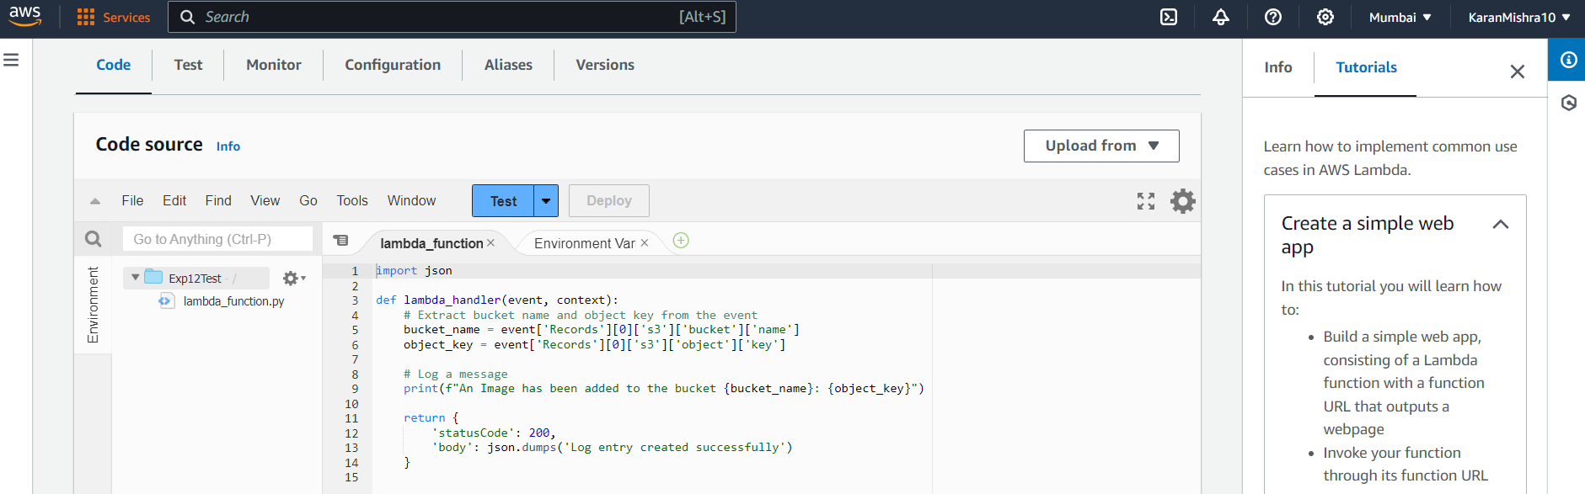  
Checking permissions:-

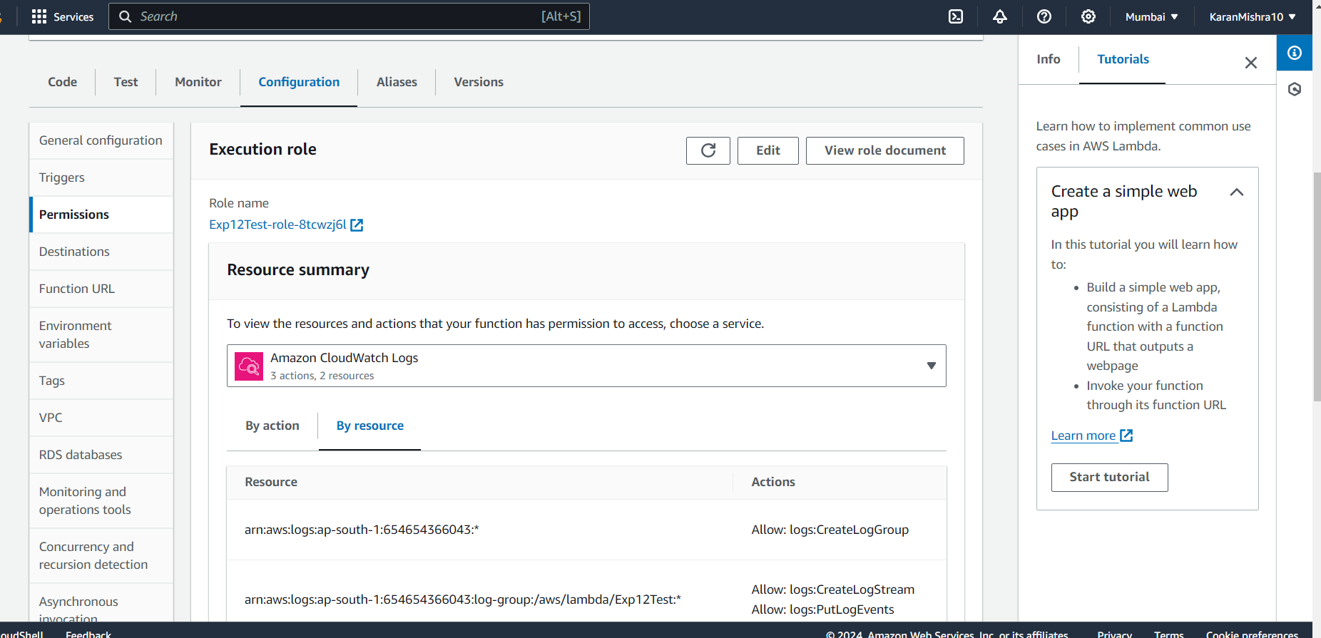

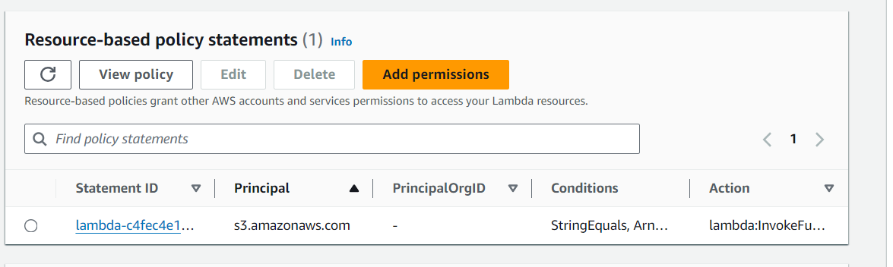

Console Output:-

